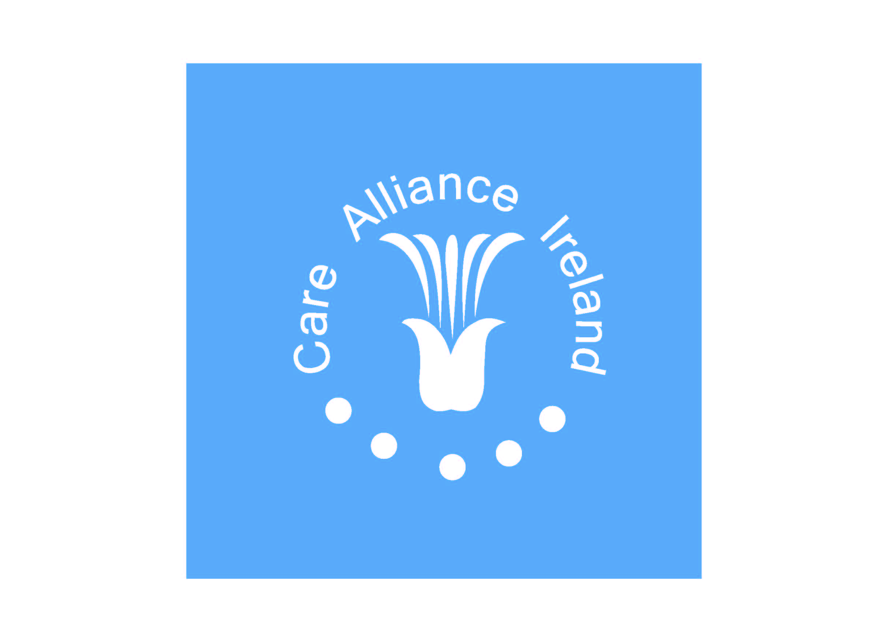

Report on Young Carers Seminar of September 19th 2011 – Facilitated by Care Alliance Ireland and Crosscare (Carer Support).

On Monday the 19th of September Care Alliance Ireland and Crosscare Carer Support Programme co-facilitated a morning seminar entitled “Young Carers Support Initiative” in the Carmichael Centre, North Brunswick Street, D7. The seminar was partially funded by a local National Lottery Grant.
The Seminar was aimed at those who work with young people and their families in a range of settings with a view to gaining:
- A better understanding of issues facing young carers
- Connection with leading practitioners in this emerging area
- Enhanced collaboration between organisations
- Movement to set up and develop additional local young carer support projects

In attendance on the day were 37 people representing 24 agencies, the majority based in Dublin. A comprehensive seminar pack was given to each participant, included in it were various research and practice resources to support those interested in developing support services for young carers, together with copies of the presentations made by the various speakers. See Appendix II for a full list of contents of the seminar pack.
The morning began with a video / YouTube presentation of current responses to young carers in the U.K and Northern Ireland.
See links below:

Young carers matter too: http://www.youtube.com/watch?v=aR7Bk5VClpc
Young Carers Guardian Angels: http://www.youtube.com/watch?v=-riqTuTS-mw
Young Carers and school: http://www.youtube.com/watch?v=7oHAvInYXDM&feature=related
Young Carers festival 2011: http://www.youtube.com/watch?v=S-7bqodzkdg
Poems by the Young Carers Revolution: http://www.youtube.com/watch?v=7r_aRq90FY8

This was followed by a presentation by Tony McGurk, Manager of Barnardo’s Northern Ireland Regional Young Carers Service which is 15 years in existence covering the following topics:
- Tracing the history of the service
- Who young carers are
- Their responsibilities
- Impacts of caring
- Services offered by their organisation
- Possible indicators of a young carer
Following a question and answer session there were two presentations on projects for young carers in Dublin and Cork. Rosemary Daynes (Crosscare Carer Support Programme), Sonnia Brady and Jennifer Kavanagh (City of Dublin Youth Service Board, CDYSB) spoke about their work with young carers in a second level VEC school, Colaiste Eoin Finglas. Linda McKiernan (Community Development worker with Cork City Partnership) outlined her findings from her thesis on young carers in Ireland and her work to date in Cork. This was concluded with a discussion with the panel on issues arising from the morning and information on other projects at different stages around the country.
Observations on the day
- Northern Ireland has a statutory response to young carers
- The issues arising from the projects in Cork & Dublin mirrored those in Northern Ireland e.g.
- Indicators of a young carer
- The challenges in identifying young carers
- The responsibilities they carry out
- Raising awareness about young carers
This might indicate that we can build on the skills and experience of work carried out to date with young carers in Northern Ireland as we begin to respond to these young people in Ireland.
A number of questions were raised at the seminar and a summary of these questions and answers are below. Some of the questions were to clarify issues raised and others highlighted broader issues including:
- How to arrive at a definition of a young carer and its implications in relation to funding and developing policy
- How to raise awareness about young carers
- What are the long term effects of caring on young people
- Child protection policy and its impact on working with young carers
- The challenges involved in gaining parental support prior to engaging with young carers
- No statutory response to young carers in Ireland

Where we go from here?
Based on issues raised on the day and feedback from the evaluation sheets completed the following actions were proposed
- Expand the working group of Care Alliance Ireland and Crosscare Carer Support group to include other interested groups
- Facilitate an annual seminar on young carers
- Come up with an agreed definition of a young carer
- Look at the implications of adult and young people’s services working separately and its impact on responding to young carers
- Bullying was raised as an issue faced by many young carers
- How can we be advocates for young carers
- Invite young carers to future seminars
- Bring out a directory of services
- Include presentations from other projects working with young carers

Commitments Made:
- Care Alliance Ireland secured permission from all participants to circulate their name and contact details to all participants to facilitate networking and collaboration and to share latest practice and information.

- Care Alliance Ireland and Crosscare committed to bring together organisations together again next year.

Questions to Panel
(Tony McGuirk, Liam O’Sullivan, Nora Kirrane, Linda McKiernan)
- What do we know about the long term affects of caring when young carers move into adulthood?
Response; (TMcG) Aware of one piece of research – moving away from home was difficult as was staying away. Forming relationships was also difficult.
- Is Barnardos Ireland working with Young Carers?
Response; (TMcG) Not that we are aware of – (LOS) We are working to encourage them to engage with us.
- Is there a time frame for working with young carers or do they link in indefinitely?
Response; (TMcG) Work with young carers for as long as they are caring and need support. May just do piece of work with young carers who are a lower priority.
- What was the percentage of single parents receiving care?
Response; (TMcG) 60% according to UK research
- Is it only the main carer who attends for support?
Response; (TMcG)Yes, Barnardos NI focus on the primary carer as they don’t have the resources to serve all of the family.
- The definition of a young carer would seem to be important when seeking funding.
Response; (TMcG) Yes. It is easier to access funding for practical care but not for emotional support. When we started we had a broad definition but funding restrictions has led to this definition narrowing. With a tight definition you can then help the group identified by research.

- How to raise awareness about young carers?
Response; Through state and voluntary organisations, visiting schools is a response but there is a reluctance in relation to self identification due to denial and stigma. Using posters and t.v. ads may be helpful but again denial and stigma may hold young carers back.
- How do you get past denial?
Response; Sometimes we have to walk away when a family won’t allow us in to work with young carer. Important to have parents support.
- How to deal with caring when alcohol and drugs involved?
Response; It is more challenging and different than caring for someone with another illness. Physical illness is more accepted while alcohol and drugs are denied. The emotion work in this case is very important. Parents may be able to carry out day to day tasks but the young carer worries about their future
10.Is the door closed more in relation to this issue?
Response; Yes

11.Do you discuss child protection with families and what impact does this have on the work?
Response; (TMcG) Parents and children sign an agreement in relation to child protection to give consent for the agency to work with the young carer. Without this agreement work cannot go ahead. If they suspect abuse they must report it.

General Questions/Discussion
Difficult to access services for young carers in the local community for hospital social workers when it’s not a child protection issue. How do we access these services?
Response; It is difficult to access services in the local community for young carers. Important to listen to them and to contact organisations like the carers association and youth services. Find out what agencies are out there and encourage them to pool resources and work together for the young carer.

Are there social networking opportunities for young carers?
Response; Yes there are blogs, online support groups etc in other countries e.g. young carers network with the Princes Trust and check out Crosscares website for other sites
See http://www.crosscare.ie/index.php?/what_we_do/community_services/carers_support/ )

Is there a statutory response to young carers in Ireland?
Response; No. Having a definition of a young carer would be a useful lever.
How to get the word out there about young carers in a local community?
Response; Young carer is an emotive title as it may make the parent feel inadequate or that they have failed as a parent if they have a young carer in the family.

Contact Details:
Liam O’Sullivan, Care Alliance Ireland. 087 207 3265 or ndo@carealliance.ie www.carealliance.ie
Crosscare -Carer Support Nora Kirrane on 01 836 0011 or
or nkirrane@crosscare.ie http://www.crosscare.ie/index.php?/what_we_do/community_services/carers_support/

Appendix II – Seminar Pack Contents


Care Alliance Ireland – Crosscare (Carers Support)
Young Carers Seminar – September 19th 2011
Pack Contents
- Seminar Programme
- List of Participants - Name and Organisation
- Press Release
- Presentation by Rosemary Daynes, Crosscare (Carer Support)
- Presentation by Tony McGurk , Barnardo’s NI
- Presentation by Linda McKernan, Cork City Partnership

- Research and Practice Resources;

  - Powerpoint of Presentation entitled ; Young carers – messages from research for Ireland by Professor Saul Becker, delivered at The Carers Association National Conference Under the Radar – A Focus on Young Carers, 7th May 2010, Croke Park Conference Centre, Dublin,
  - Executive Summary - Study of Young Carers in the Irish Population, May 2010, Office of the Minister of Children and Youth Affairs. Fives, A. et el
  - Article entitled ‘Supporting young carers and their families using a whole family approach’
  - Report entitled; Young adult carers’ experiences of barriers to further education, training and employment in Dundee’
  - The Children’s Society – Include Programme - E-Bulletin Summer/Autumn 2011
  - Toolkit for Working with Young Carers - from Cork City partnership

- List of Useful Organisations/Websites on Young Carers Issues
- Care Alliance Ireland – About Us
- Care Alliance Ireland – Membership Flier
- Care Alliance Ireland – Membership Application Form
- Crosscare (Carer Support)- Description of Services Booklet
- Carers Week Pen and Trolley Coin Holder
- Evaluation Form

