For Immediate Release Monday October 6th 2023

Family Carers Making Caring Work
Today marks European Carers Day, and is an opportunity to highlight how millions of unpaid family carers across Europe juggle caring and paid work.
Audrey Rossa from Kildare, knows all about juggling work and care. Audrey has been caring for a family member for over 20 years and recently took up part-time paid work.
“For the last number of years I really wanted to return to the workforce in some form, but didn’t know where to start, and was worried about how it would work with my homelife and caring duties”.
Commenting on how she juggles her paid work with her caring responsibilities she say’s “It is vital that I have the freedom to work hours that suit me in order to be able to attend appointments with my loved one and to be able to look after them. I work remotely, and work hours to suit myself and my family.”
The European Carers Day campaign sheds light on the urgent need for a balanced approach between work, personal life and caring responsibilities.
Care Alliance Ireland, through their Re-Emerge project, are currently working with over 80 family carers across Ireland who are seeking to return to paid work after caring for a loved one. Speaking about the project, Audrey, who is a past participant of the project, says;
“The course was brilliant and helped to give me confidence to start seeking work. It focused on confidence, personal development, IT skills, interview skills (I was terrified even thinking about it), and making up a CV. This gave me the courage to apply for a position that was only 5 hours per week. I was delighted to get the job and have since gone up to 10 hours per week.”
Care Alliance CEO, Liam O’Sullivan said “Unpaid family carers are the backbone of our society. It is time to recognise their contributions and support them in achieving a healthy work-life-care balance”.
Notes for Editors
Audrey Rossa is available for interview. Photo available on request. To arrange please call Liam O’Sullivan, CEO, Care Alliance Ireland, on 087 207 3265 ndo@carealliance.ie
Care Alliance Ireland is the National Network of Voluntary Organisations supporting family carers. Their vision is that the role of family carers is fully recognised and valued by society in Ireland. www.carealliance.ie
The European Carers Day campaign sheds light on the urgent need for a balanced approach between work, personal life and caring responsibilities. To mark this day, various events, discussions, and initiatives are taking place across Europe, highlighting the resilience, dedication, and contributions of unpaid family carers. Eurocarers, co-ordinates European Carers Day. https://eurocarers.org/ecd/
Re-Emerge is administered by Pobal and funded by the Government of Ireland through the Dormant Funds Accounts. Re-Emerge aims to support family carers with their transitions back to paid employment. This involves focusing on the family carers emotional, physical and mental well-being along with the practical training required. For more details see https://www.carealliance.ie/Reemerge
Count On Us Recruitment (where Audrey works) finds employment opportunities for Family Carers around their caring commitments https://countonusrecruitment.ie/
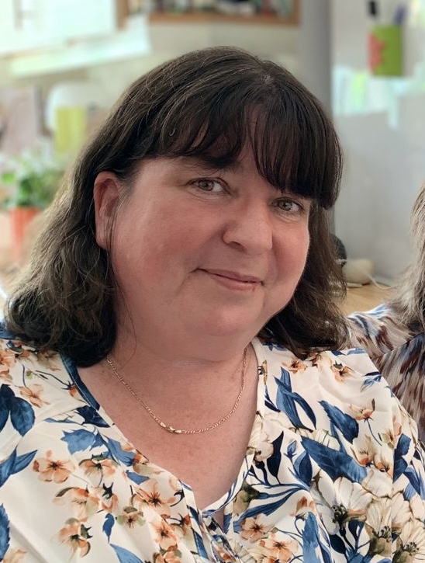
Audrey Rossa, Kildare. (Free for use)

